Worksheet 2: 20 to 24 April 2020 (Writing – two days)
The obituary
An obituary is a report or article that announces the death of someone. It contains the full name of the deceased, as well as his or her nickname, e.g. Dorothy (Dot) Anne Smithers. It mentions the person’s date of birth and death, as well as the date, time and location of his or her funeral or memorial service. It usually mentions positive, notable details about the person’s life, but in the case of a controversial historical figure, will mention the negative aspects too (no admiring obituaries about the lives of Adolf Hitler or Josef Stalin, although misguided good intentions gone wrong might deserve a mention).
The register of the obituary is FORMAL (no contractions or informal language), while its tone is solemn and respectful.
Exercise: Write an obituary
Write an obituary of 120 to 150 words about the life and death of an imaginary historical figure (could even be you) who died on 21 April 2100 at the ripe age of 97.
Day 1: Plan and write a first draft of the obituary.
Day 2: Edit your first draft and write a final draft of the obituary. While editing, check for language and spelling errors. Also make your writing more interesting by substituting more interesting and expressive words for tired words like “nice” and “pretty”. Add adjectives and adverbs that provide interesting-sounding descriptions. Take care though not to “over-write”, it should still sound interesting).
Example of an obituary
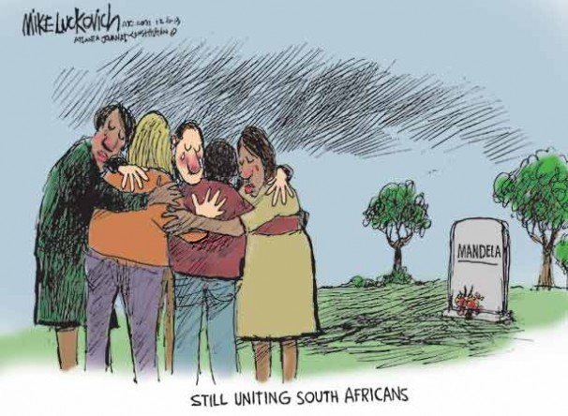
An excerpt from the BBC obituary about former President Nelson Mandela
To those who observed him closely, Nelson Mandela always carried himself as one who was born to lead.
As his former cellmate and long time friend, Ahmed Kathrada, said recently: "He was born into a royal house and there was always that sense about him of someone who knew the meaning of leadership."
The Mandela who led the African National Congress into government displayed a conspicuous sense of his own dignity and a self-belief that nothing in 27 years of imprisonment had been capable of destroying.
Although Mr Mandela frequently described himself as simply part of the ANC's leadership, there was never any doubt that he was the most potent political figure of his generation in South Africa.
o bitterness... Mandela and De Klerk
To the wider world he represented many things, not least an icon of freedom but also the most vivid example in modern times of the power of forgiveness and reconciliation. Back in the early 1990s, I remember then President, FW De Klerk, telling me he how he found Mandela's lack of bitterness "astonishing".
His fundamental creed was best expressed in his address to the sabotage trial in 1964. "I have fought against white domination, and I have fought against black domination," he said.
"I have cherished the ideal of a democratic and free society in which all persons live together in harmony and with equal opportunities. It is an ideal which I hope to live for and to achieve. But if needs be, it is an ideal for which I am prepared to die."
Born in 1918, Rolihlahla Dalibhunga Mandela was raised in the village of Qunu in the Transkei in the Eastern Cape. He was one of 13 children from a family with close links to the royal house of the Thembu people.
Mr Mandela often recalled his boyhood in the green hills of the Transkei with fondness. This was a remote landscape of beehive-shaped huts and livestock grazing on poor land.
He was only nine when his father died of tuberculosis. Always closer emotionally to his mother, Mr Mandela described his father as a stern disciplinarian. But he credited his father with instilling the instincts that would help carry him to greatness.
met future ANC leader Oliver Tambo at university
Years later Mr Mandela would write that "my father possessed a proud rebelliousness, a stubborn sense of fairness…" His death changed the course of the boy's life.
The young Mandela was sent from his home village to live as a ward of the Thembu royal house, where he would be groomed for a leadership role.
This meant he must have a proper education. He was sent to a Methodist school, where he was given the name Nelson. He was a diligent student and in 1939 went to Fort Hare University, then a burgeoning centre of African nationalism.

1918 Born in the Eastern Cape
1943 Joined African National Congress
1956 Charged with high treason, but charges dropped after a four-year trial
1962 Arrested, convicted of incitement and leaving country without a passport, sentenced to five years in prison
1964 Charged with sabotage, sentenced to life
1990 Freed from prison
1993 Wins Nobel Peace Prize
1994 Elected first black president
1999 Steps down as leader
2001 Diagnosed with prostate cancer
2004 Retires from public life
2005 Announces his son has died of an HIV/Aids-related illness
It was at Fort Hare that Mr Mandela met the future ANC leader, Oliver Tambo, with whom he would establish the first black law practice in South Africa. Both were expelled from the university in 1940 for political activism.
First as a lawyer, then an activist and ultimately as a guerrilla leader, Mr Mandela moved towards the collision with state power that would change his own and his country's fate.

